**Cluck Track**

**Made to protect your finance**



**Submitted by:**

Faaez 2022-CS-836

Umar Farooq 2022-CS-811

**Submitted To:**

Mr. Mohsin Sheraz

Department of Computer Science

**University of Engineering and Technology**

**Lahore Pakistan**

Table of Contents

1. Executive Summary 3

2. Overview 3

3. Client Requirements 3

• Dashboard: 3

• Profit Analysis 3

• Expense Tracking: 3

• Sales Management: 3

4. First Revision from Client 3

5. System Features 4

6. Security Features 4

• User Authentication 4

• Password Management 5

• Least Privilege Policy 5

• Limited User Rights 5

• SQL Injection Prevention 5

• Email Verification with Machine IP and Source For Tracking 5

7. Implementation Details 5

8. Entity Relation Diagram 6

9. Conclusion 7

# Executive Summary

Cluck Track is a poultry management system tailored to meet the specific needs of poultry farm owners and managers. The system provides essential functionalities including a dashboard for quick insights, profit analysis, expense tracking, and sales management. By offering intuitive interfaces and robust calculation tools, Cluck Track aims to streamline operations, optimize profitability, and enhance decision-making for poultry farms.

# Overview

Cluck Track simplifies poultry farm management by focusing on key areas of concern for farm owners and managers. The system provides tools for monitoring profits, tracking expenses, and managing sales transactions. With a user-friendly dashboard and efficient calculation capabilities, Cluck Track empowers users to make informed decisions and drive business growth.

# Client Requirements

## Dashboard:

The project's core functionalities, including profit, Expense, Sales, No. of Hens, Roasters, Chicks and Death of Poultry are listed on Dashboard. Moreover, the profit or loss is also present on dashboard for better business analysis.

## Profit Analysis

The client emphasized the importance of detailed profit analysis, including calculations based on sales revenue and expense deductions.

Comparative analysis of profits across different periods and categories was identified as a crucial requirement.

## Expense Tracking:

Comprehensive tracking of expenses incurred in poultry farm operations was requested by the client.

The system should support expense categorization for detailed analysis and reporting purposes.

## Sales Management:

Efficient management of sales transactions, including recording, tracking, and analysis, was highlighted as a key requirement.

The client expects insights into sales trends and patterns to inform marketing and production strategies.

# First Revision from Client

* Custom Categories

In response to client feedback, custom categories for expenses and sales were added to the system.

This enhancement allows users to categorize expenses and sales according to their specific needs and business requirements.

* Software Reset

The client requested the ability to reset the software by erasing all data.

This feature was implemented to provide users with the option to start fresh if needed, ensuring flexibility and ease of use.

# System Features

* User Authentication

Authentication mechanism ensures that only authorized users, including the admin, can access the system.

* Dashboard

Provides a dashboard displaying essential metrics such as profit, expenses, sales, mortality, number of eggs sold, and livestock count (chicks, hens, roosters).

* Transaction Management

Users can add sales, expenses, poultry deaths, and purchases.

Users can convert chicks to hens and roosters as needed.

* Category Management

Admin can manage transaction categories to organize data effectively.

* Date-wise Transaction Viewing

Admin can view sales, expenses, deaths, and purchases filtered by specific dates.

* User Administration

Admin can manage user accounts, adding or removing access as necessary.

* Reporting

Admin can generate reports containing all transactions within a specified date range.

Report includes details such as profit, loss, expenses, and mortality.

* Data Management

Admin has the option to reset all data, allowing a fresh start if needed.

# Security Features

* User Authentication

Email-based Username: Users can only add email addresses as usernames, enhancing security and ensuring unique identification.

Password Change Verification: Requires users to authenticate password changes via random code sent to their email, preventing unauthorized access.

* Password Management

Secure Password Changes: Implements a secure password change process using email verification, enhancing account security.

Password Resets: Utilizes email-based random code verification to securely reset passwords, preventing unauthorized access.

* Least Privilege Policy

Limited Rights: Adheres to the principle of least privilege, granting users only the necessary rights to perform their tasks, minimizing the risk of unauthorized actions.

* Limited User Rights

Restricted Access: Users have limited rights to the system, ensuring that they can only perform authorized actions and minimizing the risk of misuse or data breaches.

* SQL Injection Prevention

Function-based Security: Implements functions to disable SQL injection attacks, protecting the system from potential vulnerabilities and ensuring data integrity.

## Email Verification with Machine IP and Source For Tracking

Enhanced Verification: Email verification for password changes includes machine IP and source form tracking, providing additional layers of security and accountability.

# Implementation Details

Developed using C#, .NET Framework, Windows Forms, SQL, and Azure services.

Utilizes C# for backend logic and business rules implementation.

Implements Windows Forms for the frontend user interface, ensuring compatibility and ease of use.

Utilizes SQL for database management and data storage.

Leveraging Azure services for cloud-based infrastructure, scalability, and security enhancements.

# Entity Relation Diagram

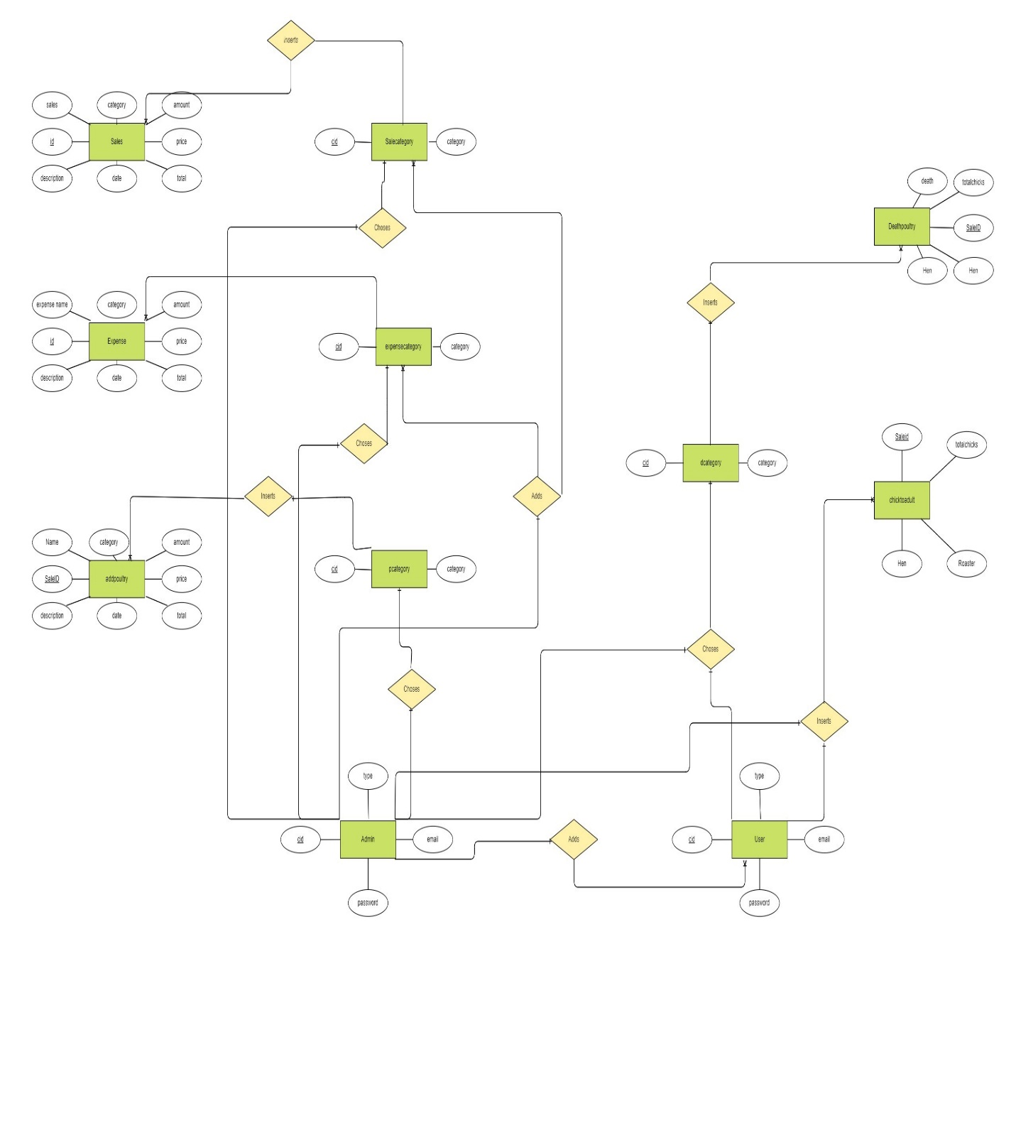

# Conclusion

In conclusion, Cluck Track represents a significant advancement in poultry management systems, offering a comprehensive solution for poultry farm owners and managers. By harnessing the power of technologies such as C#, .NET Framework, Windows Forms, SQL, and Azure services, Cluck Track provides a robust and scalable platform for optimizing poultry farm operations.

The system's emphasis on security is evident through its implementation of email-based authentication, secure password management, least privilege policy, SQL injection prevention, and email verification with machine IP and source form tracking. These measures ensure data integrity, protect against security threats, and instill confidence in users regarding the safety of their information.

Furthermore, Cluck Track's user-friendly interface, centralized dashboard, and reporting capabilities empower users to make informed decisions, monitor key metrics, and drive business success. With features like user management, data reset options, and integration with cloud services, Cluck Track remains flexible and adaptable to the evolving needs of the poultry industry.

As the poultry industry continues to evolve, Cluck Track stands ready to meet the challenges and opportunities ahead. With a commitment to ongoing improvement and innovation, Cluck Track remains dedicated to providing poultry farm owners and managers with the tools they need to thrive in today's competitive market landscape.